Project Awesome

Time System Document

**Table of Contents**

1 Introduction 3

2 Design Goals 3

3 System Behavior 3

4 Logical View 4

4.1 High-Level Design ……………………………………………………………… 3

**4.2 Mid-Level Design** ……………………………………………………………..... **3**

4.3 Used Case of Main Menu ……………...………………...…………………….. 4

Change History

**Version:** <0.1>

**Modifier:** <Brandon Coates>

**Date:** 16/03/2021

**Description of Change:** First Edition for Alpha 1

**Version:** <0.2>

**Modifier:** <Brandon Coates>

**Date:** 12/04/2021

**Description of Change:** Implemented Recommended Changes to Charts and Information

# Introduction

This document describes the architecture and design for Project Awesome being developed for Team Awesome. Project Awesome is a Single Player casual puzzle game.

The purpose of this document is to describe the architecture and design of the Main Menu.

# Design Goals

The design priorities for the game system are:

* The design should be highly open to iterations and changes, with the possibility to easily switch between menus and gameplay.

# System Behavior

The game is built with only a single level completed. The rising and setting of the sun would remain the same for other levels. However, the time in which the player can complete the level may be subject to change.

# Logical View

## High-Level Design (Architecture of the Entire system)



* Game Mode is the base of game.
* Time System interacts directly with the level to change the lighting and position of the sun.

## Mid-Level Design

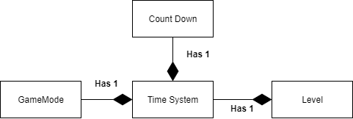

* The Time System gives a day/night cycle to the game which enhances the visuals of the game.
* The Time System will also be used to place the player on a timer to complete the level, which will be visible as UI (to be completed).

## Use Case of Time System

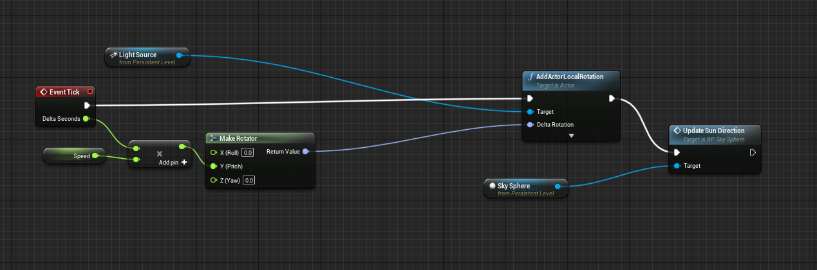

* Using one float as a speed variable, it controls the speed at which the sun rises and sets in the level.
* The light source and sky sphere in the level are rotated to update the sun direction.